Cleaning of Drainage Line, Sewage Pipeline Networks & maintenance

Proper waste treatment and free-flowing plumbing lines are critically tied to one another. Of the many products marketed which claim to aid plumbing problems, Pavitra sewage treatment product are unique. They offer a combination of micro organisms, enzymes (biochemical catalysts) and other ingredients which act together naturally to soften, loosen, remove and break down greases, fats and oils in plumbing lines, sewer systems, pump stations and treatment plants, thus keeping them clean and odor free.
Developed through the microbial technologies, Pavitra sewage treatment products, whether dry or liquid are capable of safely and effectively loosening and digesting the troublesome substances, which clog drainage systems and cause odors. When used on a regular basis, Pavitra sewage treatment products can result in savings on operational and maintenance costs.

Domestic Sewer Networks
Domestic sewer networks often contain areas in which FOG will accumulate. These areas can be lift stations or pipe segments with relative low flow. Pavitra sewage treatment bioformulations for FOG degradation are considered to be most effective microbial products to solve and prevent these systems from fouling and will bring down overall maintenance cost. Additionally keeping the sewer lines free flowing will also improve wastewater treatment operations as less FOG is flowing into the treatment plant.
How Pavitra Sewage treatment product works?
Rugged, semi-submersible cylinders that slowly dissolve and release microbes and enzymes that can reduce odor and improve sewage degradation in grease traps and lift stations.

Restaurant, Fast Food, Hotel Kitchens
Restaurants, fast food, hotel and other commercial operations with kitchens can experience clogged drains caused by FOG accumulation. These situations always occur at inconvenient times when the kitchen is in full operation and cause serious disruptions. The costs for emergency interventions are considerable.
For more information on how to treat drains and traps in restaurant & hotel kitchens contact us directly.

Sanitary cleaning
In the field of sanitary cleaning Pavitra Environment Technologies offers a range of environmental friendly cleaning products, urinal blocks and deodorizers. Contact us for detailed information.
Further to that, we offer annual maintenance contract for the sewer cleaning and sanitary cleaning for the clients of Urban Local Bodies, Municipal Corporations, Industrial, societies etc.

Where it can be used??

- Urban Drainage line of Municipalities/Nagarpalika
- Individual housing colonies
- Septic tanks
- Canteens
- Hotels, restaurant kitchens, hotels
- Mega kitchens of temples
- Educational institutes
- Public Utilities

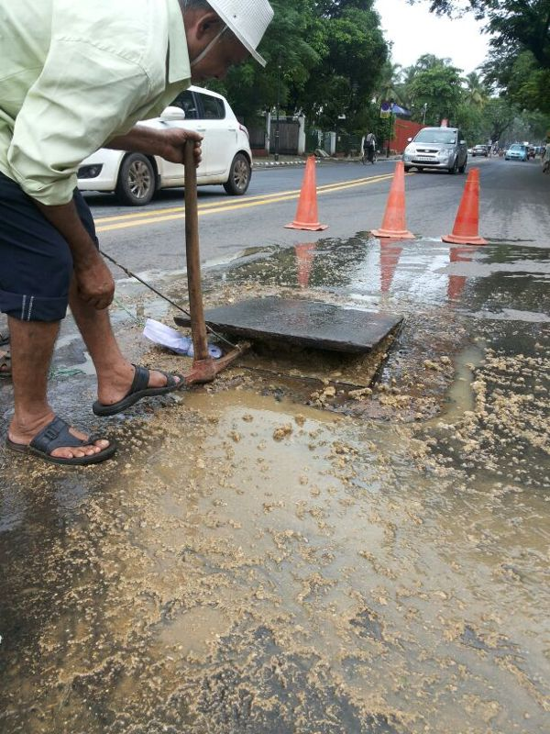
FOG CAUSED CLOGGING
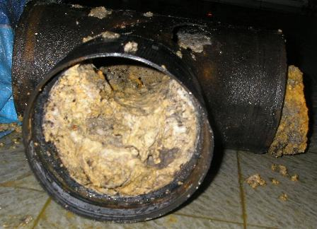

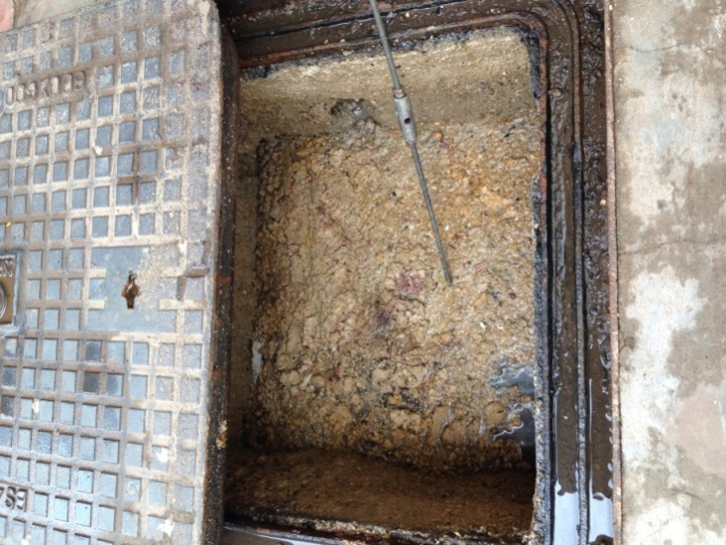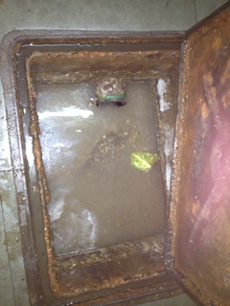
BEFORE AFTER

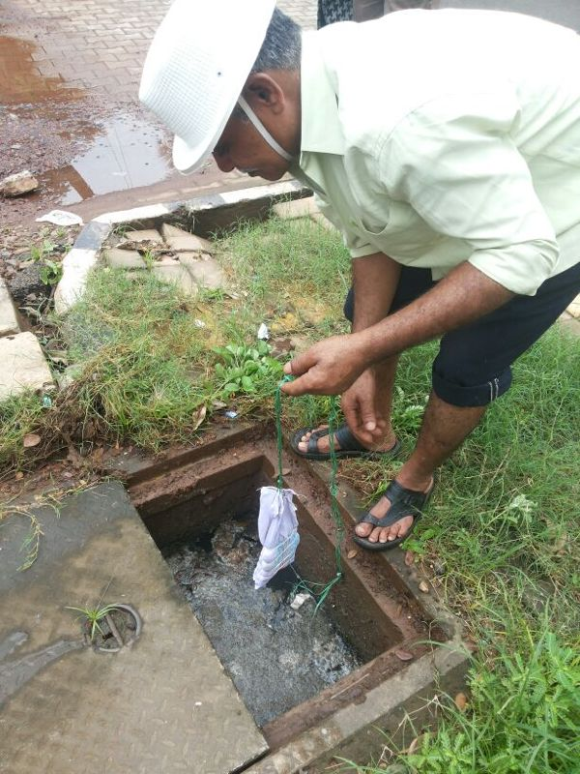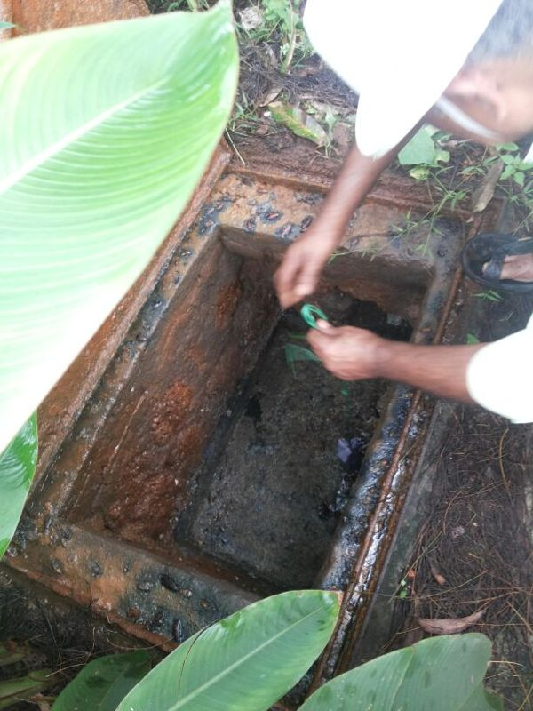
APPLTING METHODS (REDUCE IN SEWAGE LEVEL)

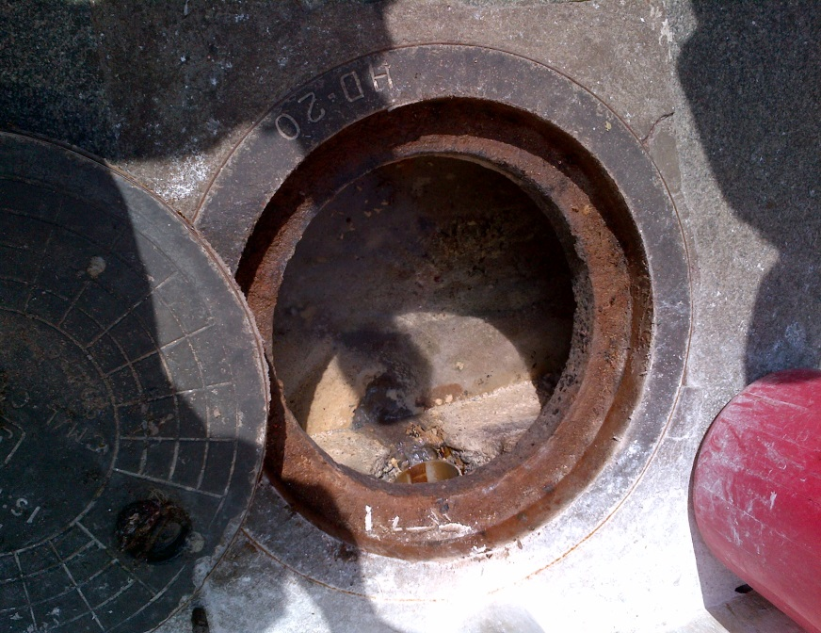
BEFORE

AFTER

